**Declaration of Conformity (DoC)**

## We, Shenzhen DOKE Electronic Co., Ltd

801, Building3, 7th Industrial Zone, Yulv Community, Yutang Road, Guangming District, Shenzhen, China.

**Declare that the DoC is issued under our sole responsibility and belongs to the following product(s): Product Type:** Tablet PC

**Trademark**： Blackview, OSCAL

**Model Number(s):** Pad 30 WiFi, Tab 20 WiFi

(Name of product, type or model, batch or serial number) System components:

Antenna type: Internal Antenna

Antenna gain: 2.4GWi-Fi: 0.5dBi Bluetooth/ BLE: 0.5dBi 5GWi-Fi: -0.8dBi

Adapter:

Model:QZ-01004AA00

Input:100-240V AC,50/60Hz 0.3A Output:5.0V DC 2.0A(10.0W)

Manufacturer: Guangdong Quanzhi Technology Co., Ltd

Rechargeable Li-ion Battery:

Model: U3050139PV-UTL; Specification: DC3.8V/6600mAh, 25.8Wh Manufacturer: SHENZHEN UTILITY ENERGY CO.,LTD

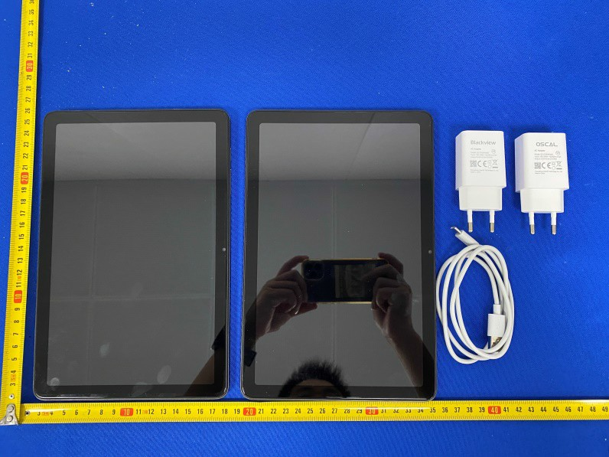

##### The object of the declaration described above is in conformity with the essential requirements of the relevant Union harmonization legislation: Radio Equipment Directive *RED (2014/53/EU)*.

**The following *harmonized* standards and technical specifications have been applied:**

**HEALTH & SAFETY (Art. 3(1)(a)):** EN IEC/IEEE 62209-1528:2021 EN 50566:2017+A1:2023

EN 50663:2017

EN 62479:2010

IEC 62368-1:2018

EN IEC 62368-1:2020+A11:2020

###### EMC (Art. 3(1)(b)):

ETSI EN 301 489-1 V2.2.3 (2019-11)

ETSI EN 301 489-3 V2.3.2 (2023-01)

ETSI EN 301 489-17 V3.3.1 (2024-09)

ETSI EN 301 489-19 V2.2.1 (2022-09) EN 55032:2015+A1:2020

EN 55035:2017+A11:2020

EN IEC 61000-3-2:2019+A1:2021 EN 61000-3-3:2013+A2:2021

###### Radio Spectrum (Article 3.2):

EN 300 328 V2.2.2 (2019-07);

EN 300 440 V2.2.1(2018-07)

EN 301 893 V2.1.1 (2017-05);

EN 303 413 V1.2.1 (2021-04);

**Notified Body Involved:**

**NOTIFIED BODY:**

# Name: DERYCOM CERTIFICATION SERVICES, INC.

Address: 1100 Falcon Avenue Glencoe, Mn 55336

|  |
| --- |
| Notified Body ID number: 3052  EU-type examination certificate number: JEC-02 |

RF Specification:

Max power:

BT:8.30dBm

2.4G WIFI:17.35dBm

5.2G WIFI:15.53dBm

5.8G WIFI:12.17dBm

Tx frequency: Wi-Fi:

2412MHz~2472MHz

5150MHz~5250MHz

5725MHz~5850MHz

Bluetooth/ BLE: 2402MHz~2480MHz Rx frequency:

Wi-Fi: 2412MHz~2472MHz

5150MHz~5250MHz

5725MHz~5850MHz

Bluetooth/ BLE: 2402MHz~2480MHz GPS: 1575.42MHz

FM: VHF band ll: 87.5MHz to 108MHz

Tests for SAR are conducted using standard operating positions with the device transmitting at its highest certified power level in all tested frequency bands. The maximum SAR values tested on this device when used in its normal position at the ear and when used close to the body (at a minimum distance of 0mm) are:

|  |  |  |
| --- | --- | --- |
| Max SAR Value(W/kg) Limit is 2.0(W/kg) for 10-g | 10-g Body | 0.895W/kg |
| Limit is 4.0(W/kg) for 10-g | 10-g Member DAS | 0.895W/kg |

Technical file held by: Shenzhen DOKE Electronic Co., Ltd

801, Building3, 7th Industrial Zone, Yulv Community, Yutang Road, Guangming District, Shenzhen, China.

**Signed for and on behalf of:** Shenzhen DOKE Electronic Co., Ltd

|  |  |
| --- | --- |
| **Name and Title:** | Chenzexiong/ Manager |
| **Address:** | 801, Building3, 7th Industrial Zone, Yulv Community, Yutang Road, Guangming District, Shenzhen, China. |



Signature of Authorized Person

2025-5-21